How to increase root EBS volume size.
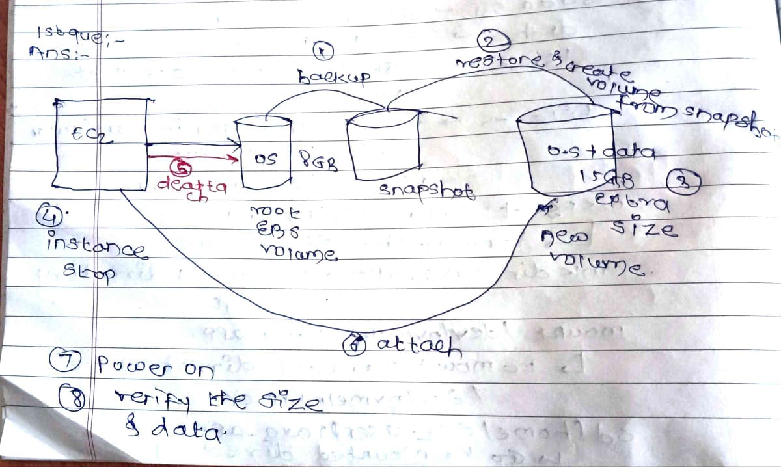

- Create a instance
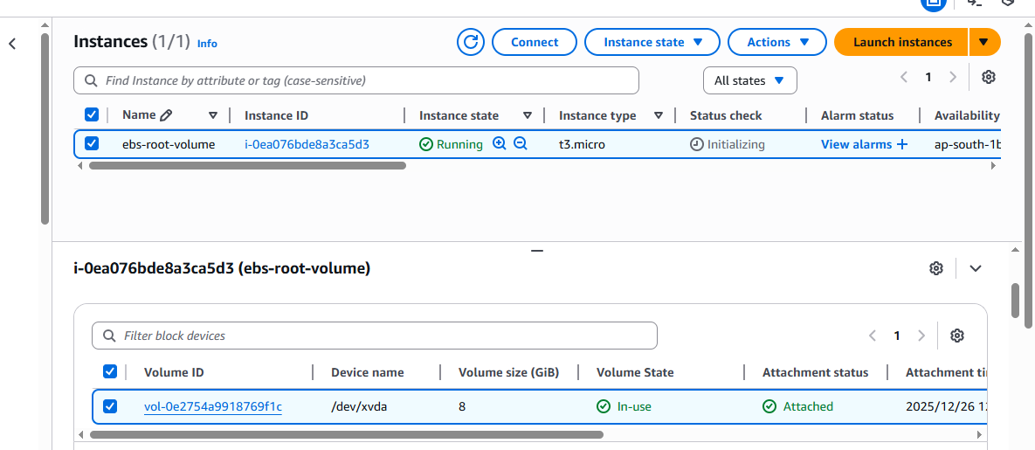
EC2 instance connect and create a data file in root volume to verify the data
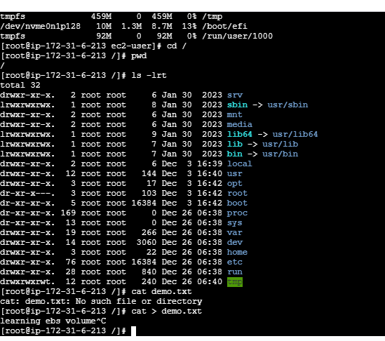

- Create a snapshot (backup) from root volume
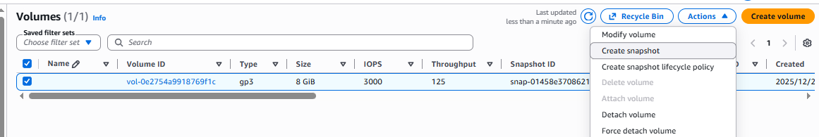
- Snapshot created from volume
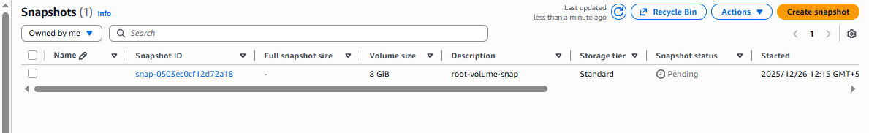
- create (restore) the volume from snapshot and add extra spcace (8gb – 15 gb)
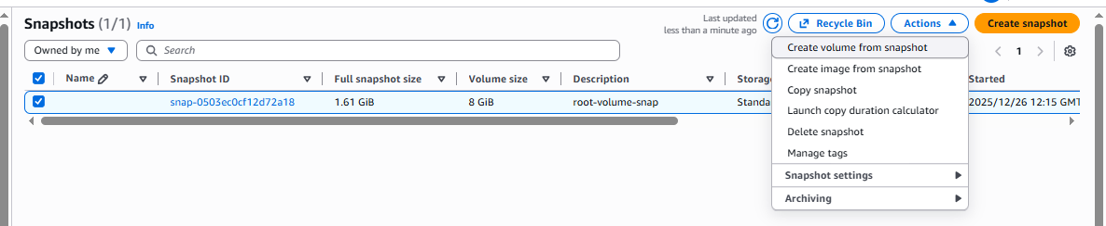

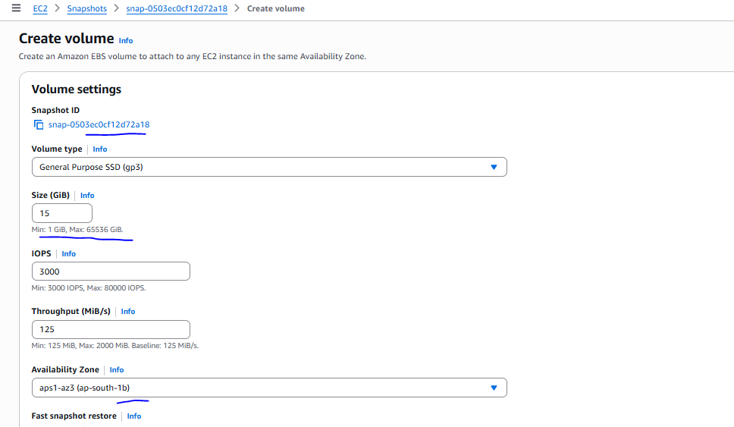

While creating the volume from snapshot should be the same AZ, and we can also change volume type if we want.

Volume has been created from snapshot
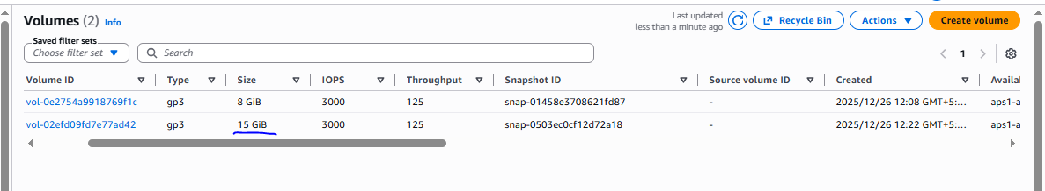

- Need to stop the instance to attached the root volume which we created with extra space.
if not stop and try detach previous root volume of instance so we can not able to detach

Instance stopped

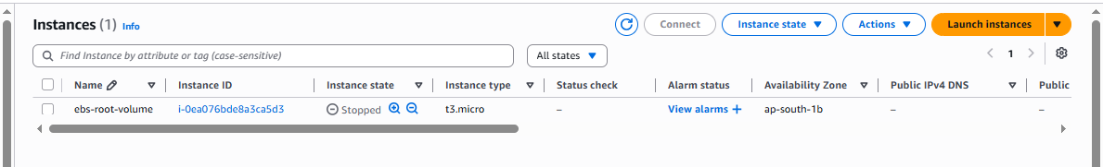

- Detached the root EBS volume
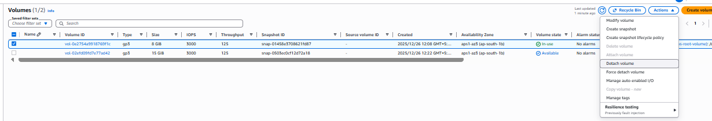
Volume has been detached successfully
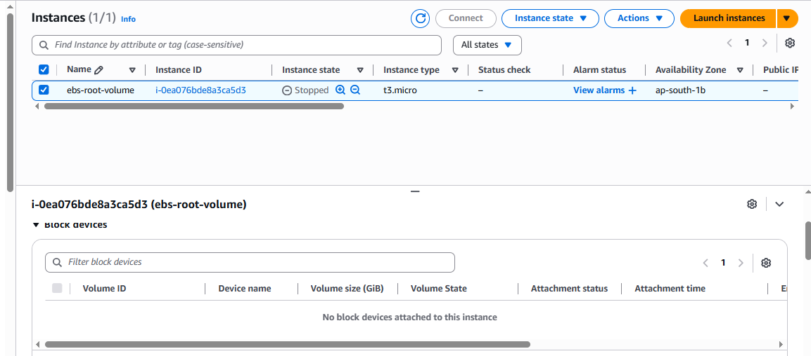

- New volume aattached
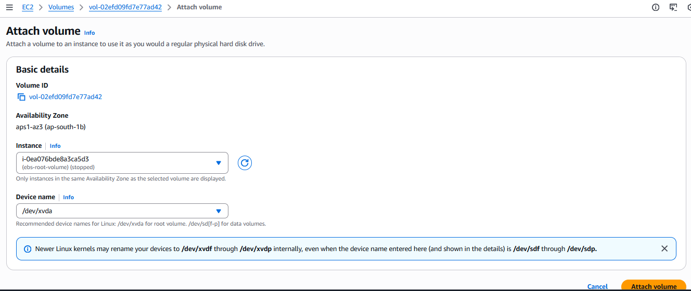

Start the instance

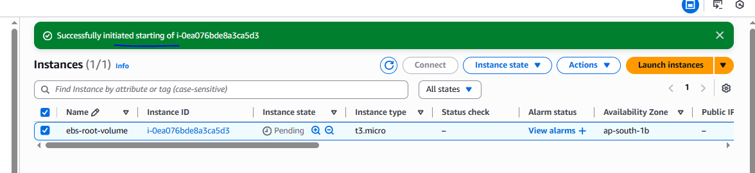

- New volume attached with extra size
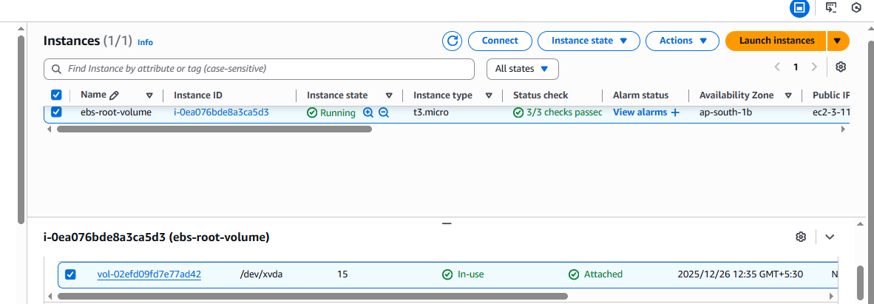
- Data is not lost.
